Alexander’s Way Research Fund, Inc.

(a 501(c)3 nonprofit org.)
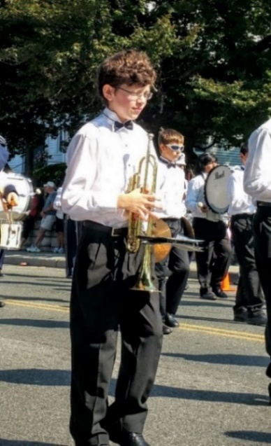
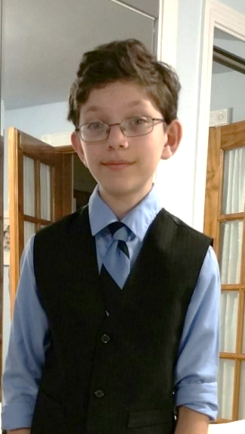
PLEASE DONATE!!!
Send your check to:
Alexander’s Way Research Fund, Inc.
353 Miller Avenue, Sheffield, MA 01257
or
Donate online at:
www.alexandersway.org
tel. 413-229-9075
Dear Community,
My name is Laura Zah.
I am a nurse and the mother of a 13-year-old boy, Alexander Zah-Greenspan, recently diagnosed with a rare genetic mutation. This mutation causes Myofibrillar Myopathy (MFM6), which results in cardiac and respiratory failure. It is expected to progress rapidly and be fatal in childhood or adolescence. This genetic mutation happened spontaneously and is not carried by our family.
Our journey to obtain a diagnosis has been long and challenging. We began in 2012 at Baystate Medical Center, then to UMass Medical Center, Boston Children’s Hospital, and finally to National Institute of Health, in Washington DC. We received his diagnosis two days before Mother’s Day in May 2016.
Our son, Alexander is lucky in many ways. He continues to be fully functional and only minimally affected by this cruel mutation. He can still run and jump and walk long distances without trouble. Alexander is very advanced academically, is proficient musically (first chair trumpet), and is part of the high school jazz band. He will soon take part in a national competition of high school bands in Nashville, Tennessee. He loves to play jazz, and he happily hums through everything he does. He loves his life…!!!
The news of this genetic mutation and its expected outcome is devastating for our whole family. It is inconceivable that a wonderful boy with such potential will rapidly decline and likely die.
Our search for treatment and clinical trials has been nonproductive. We were led to believe that because of the rarity of the mutation and lack of funds, there will likely never be any treatments or therapeutic interventions. We cannot remain passive and allow my son to perish. We are desperately hoping to be heard by people like you, who can help. Even if Alexander were the only one with this rare disease, he should have the chance to live. Developing the appropriate treatment, now, can preserve his quality of life.
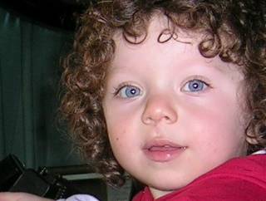
We have located several research teams, worldwide, knowledgeable about this specific genetic mutation who have agreed to collaborate to accelerate the development of treatments for Alexander and others affected by this mutation. These treatments could save my son as well as all others affected by this devastating disease. Your donations will make this possible!
Please Donate! With sincere gratitude,
Laura Zah, Stephen Greenspan, Sophia and Alexander Zah-Greenspan
Alexander’s Way Research Fund, Inc

